

SAVING CHANGES TO A DOCKER CONTAINER
DevOps Certification Training

support@intellipaat.com
+91-7022374614
US: 1-800-216-8930(Toll Free)

SAVING CHANGES TO A DOCKER CONTAINER
Step 1: Pull the docker container using the command:
$ docker pull ubuntu

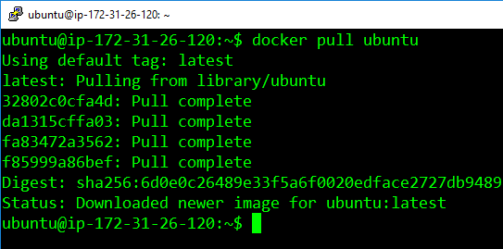
Step 2: Run the container using the commands
$ docker run –it –d ubuntu

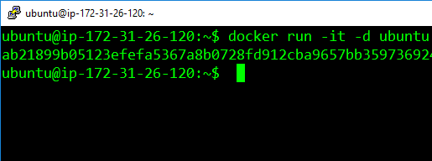
Step 3: Access the container using the command:
$ docker exec –it <container-id> bash
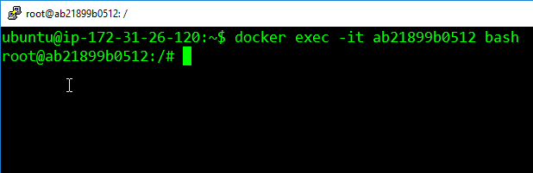
Step 4: Install apache2 on this container, using the following commands
$ apt-get update
$ apt-get install apache2

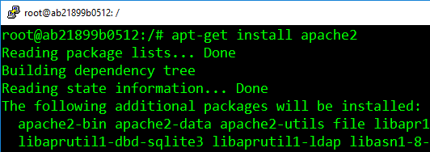

Step 5: Exit the container, and save the container using this command. The saved container will be converted into an image with the name specified is
$ docker commit <container-id> <username>/<container-name>

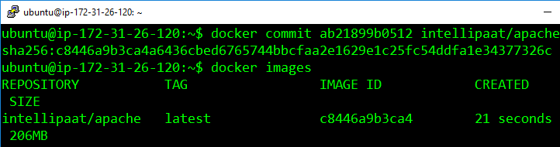
The username must match with the username which you created on dockerhub. The container-name name can be anything.

